**FARMER MODULES**

**The farm interface should look like this : ( like this template)**

**No need of the map and other things on the screen I just mean the template should be this way**

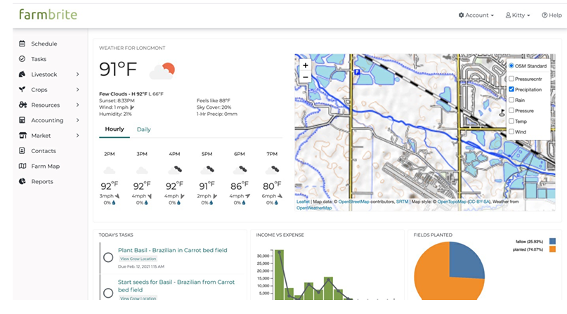

1. **Authentication**

* Login/Register
* First_name
* Last_name
* Dob
* Gender
* Phone
* Email
* Address
* country
* Farm_name
* Farm_address
* Farm_size
* Farm_type(Crop, livestock, mixed)

1. **Farm schedule: In this module, the farmer himself makes events on the calendar and they get displayed on the side as running events**

**Refer to this video for calendar format:** <https://youtu.be/nTIMYHJRW1c?si=A9HCu0SDhdwxhAiB>

 Crop Planning and Scheduling

* + Calendar-wise scheduler for:
    - Crop Planting
    - Irrigation
    - Crop Rotation

The calendar should look like this:

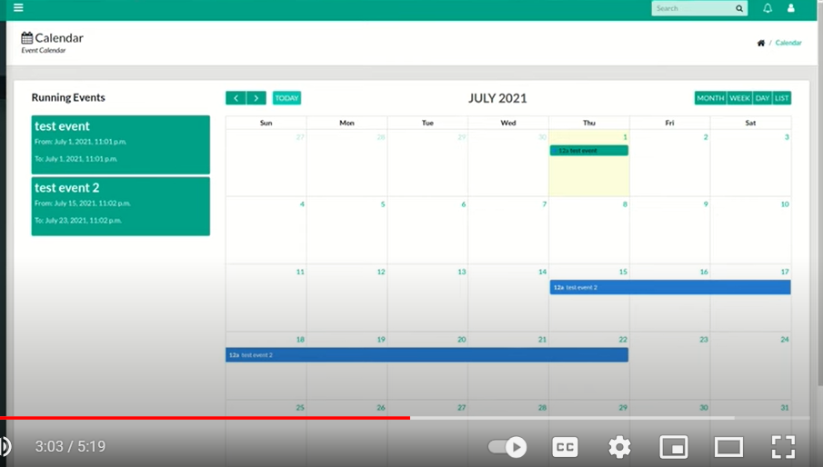

To add the event ( it look like):

* Event_title
* Description
* Start_date
* End_date
* Priority ( also add a color option like red, yellow, or orange to show the priority of the task )

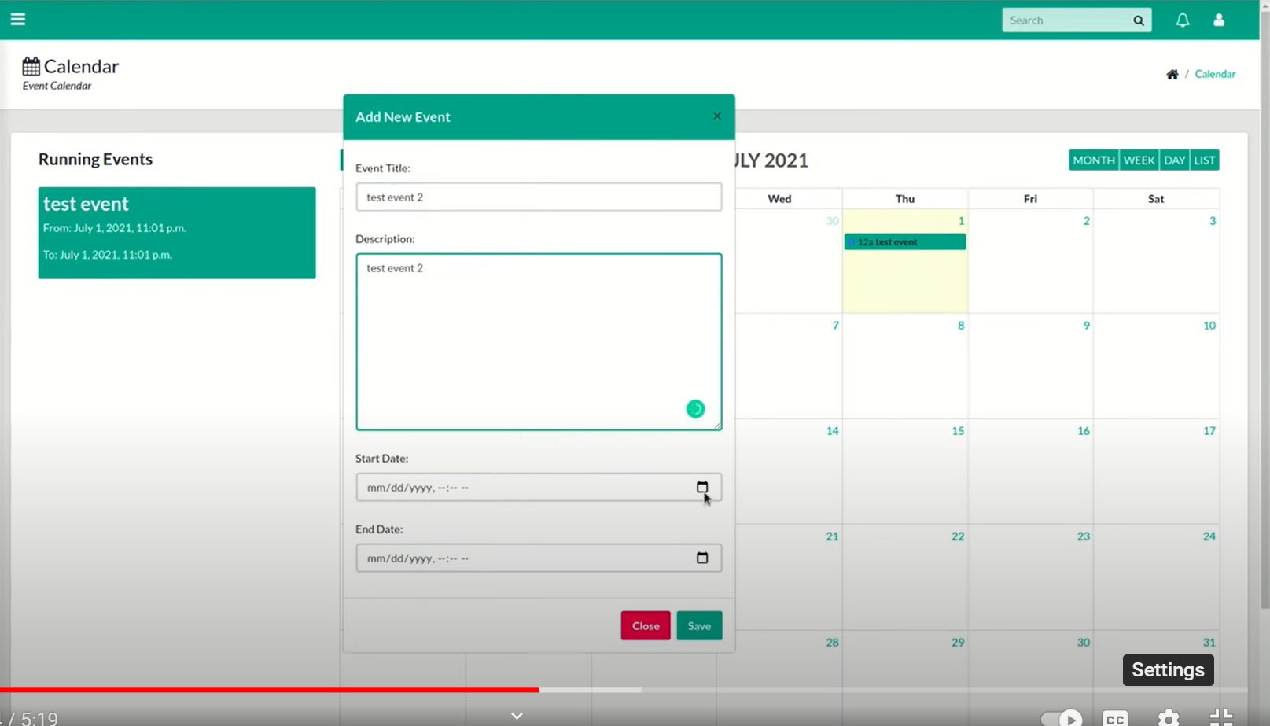

** Task**

* + List of tasks with details such as:
    - Task Name
    - Due Date
    - Assigned Worker
    - Status
    - Description
    - Add_Checklists
    - Color (showing priority – no need of a lot of colors just yellow , orange , red to show priority)

It should look like this :

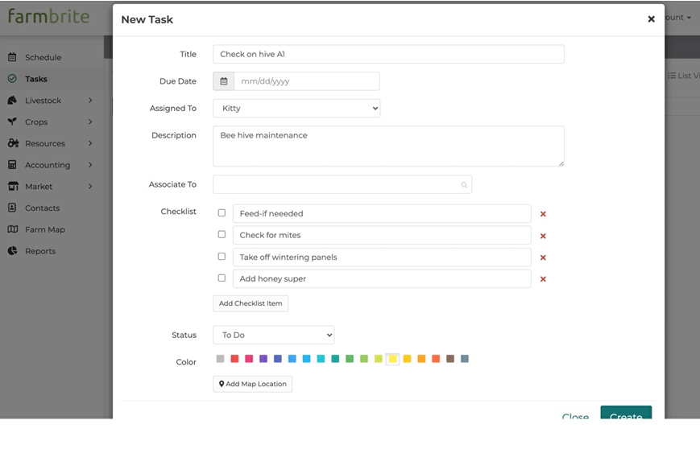

( no need of the - associate to option and map option)

We should also have the option to print the tasks and also search by task, date, worker, status

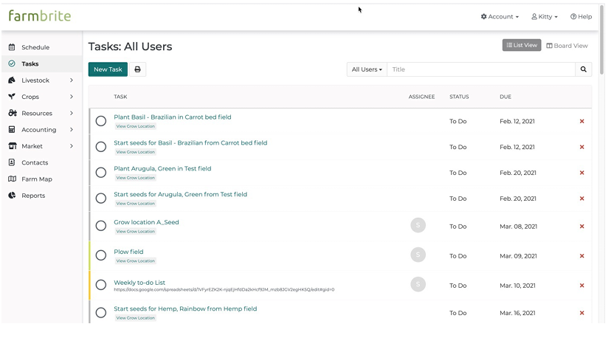

1. **Soil Testing**

 Book for Soil Test  Publishing Results

* Prediction of Required Soil Nutrients and Fertilizers

1. **Resource Tracking**

Make a main option in the name of Resource under that add two sub options like crop and livestock

**CROP TRACKING**

In the crop option,

We must be able to create, delete and update crop details

For adding crop we need fields like :

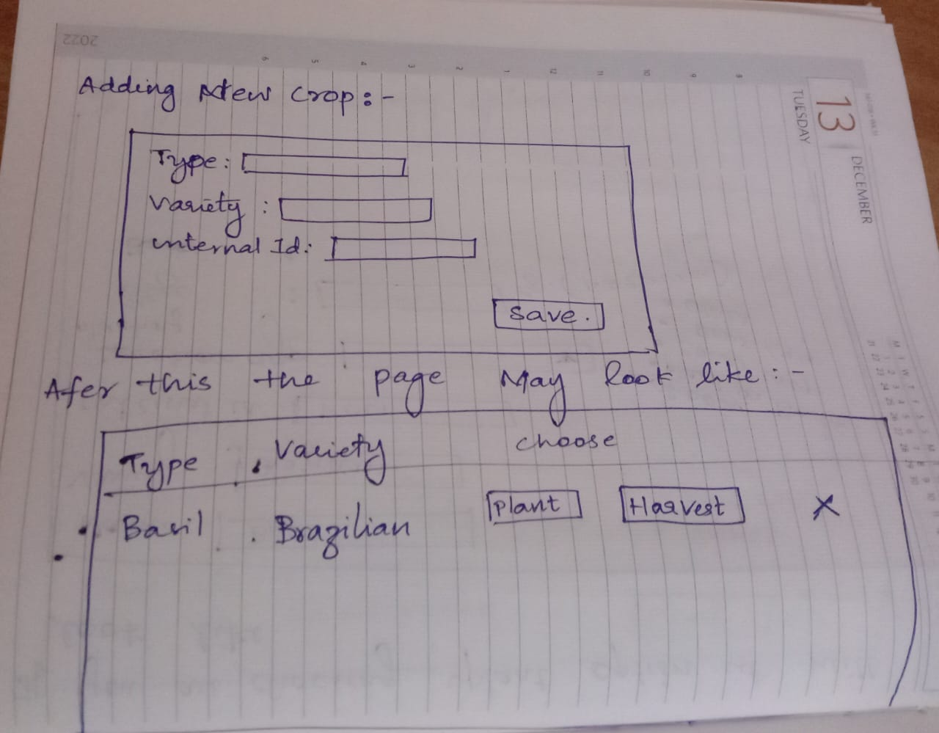

If you click the plant option :

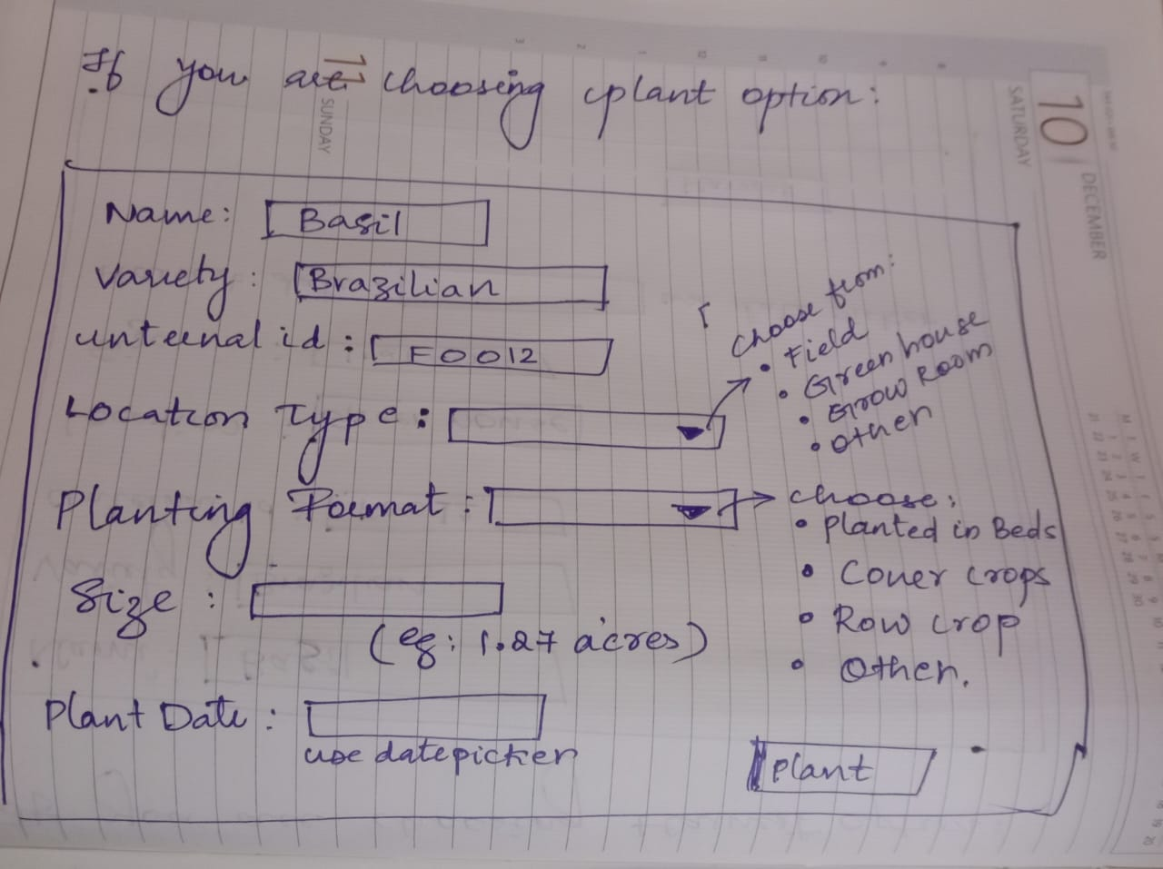

If you are choosing the harvest option :

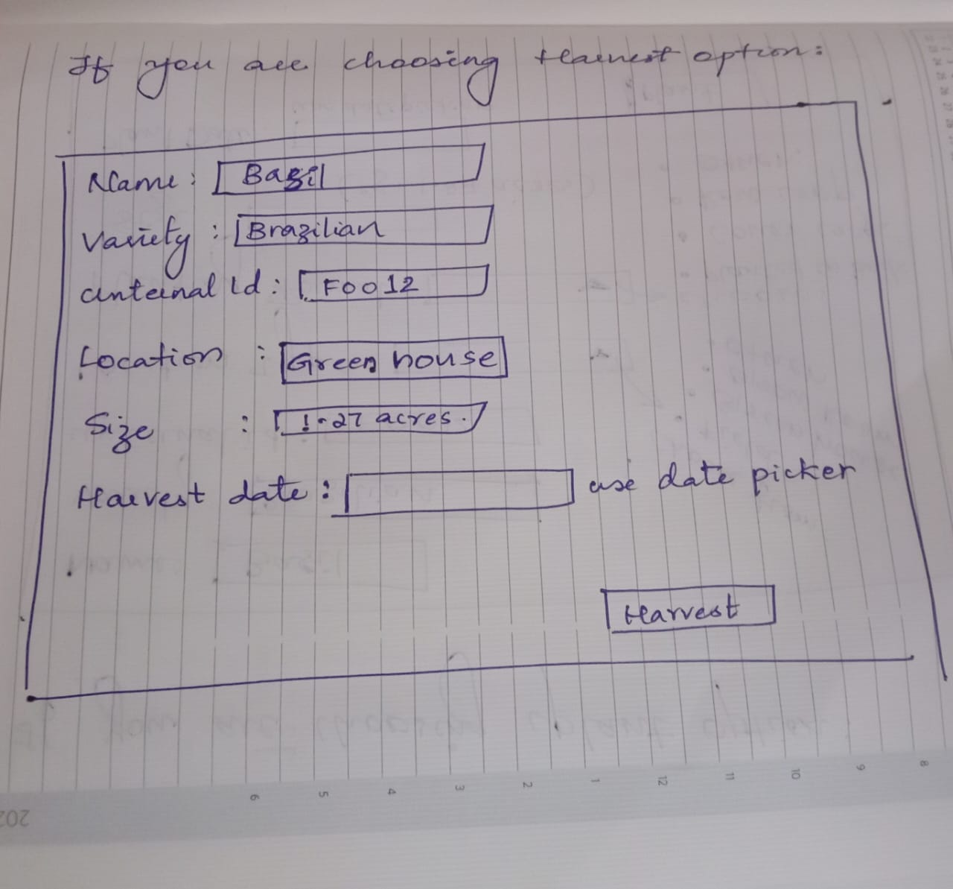

We also need an option to see the details of all plants:

Note : Make an option to print this list and also a search option to search by type, variety, date, location, etc...

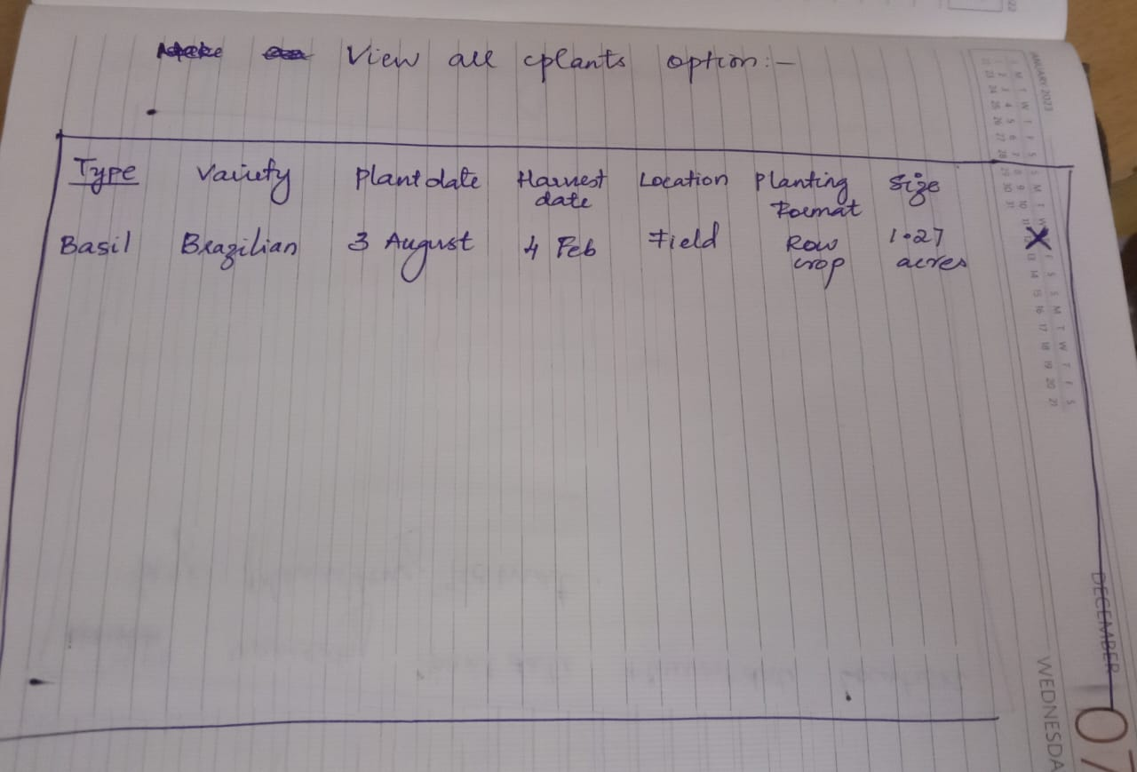

**LIVESTOCK TRACKING**

To add a livestock:

Also we must be able to create , delete , update the animal details

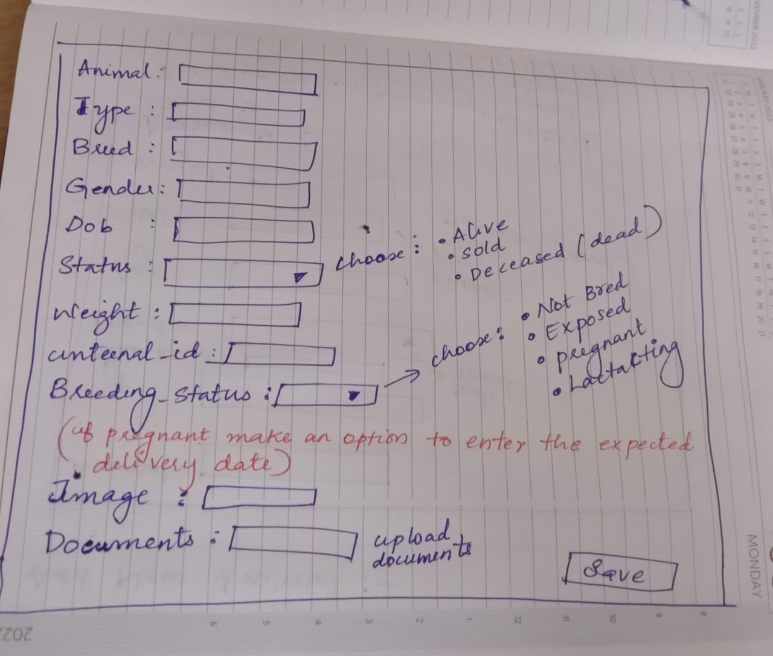

**After adding the livestock we have to show a page showing the details of all the livestocks and it should contain details like :**

* Animal
* Type
* Breed
* Gender
* Dob
* Status
* Weight
* Breeding status
* Image
* Documents ( we must be able to download from there )

1. **Inventory Tracking**

For inventory tracking, we do tracking for items like types of equipment, vehicles, harvest, etc .

Like this :

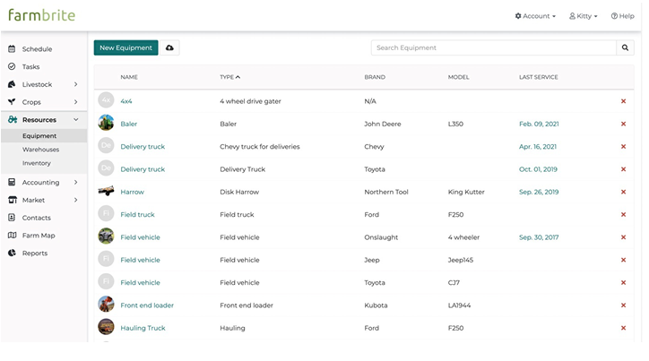

Under the option Inventory

, we need to have a sub option like Equipments in which we need to have fields like :

* name
* type
* brand
* model
* last service

we must also have an option to search the equipment and also

1. **Accounting**

In the accounting module keep two sub-options, called Transactions and P & L (profit and loss statement ) like this :

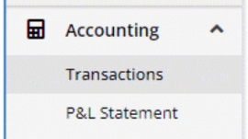

1. **In transactions: to Record or add a transaction :**

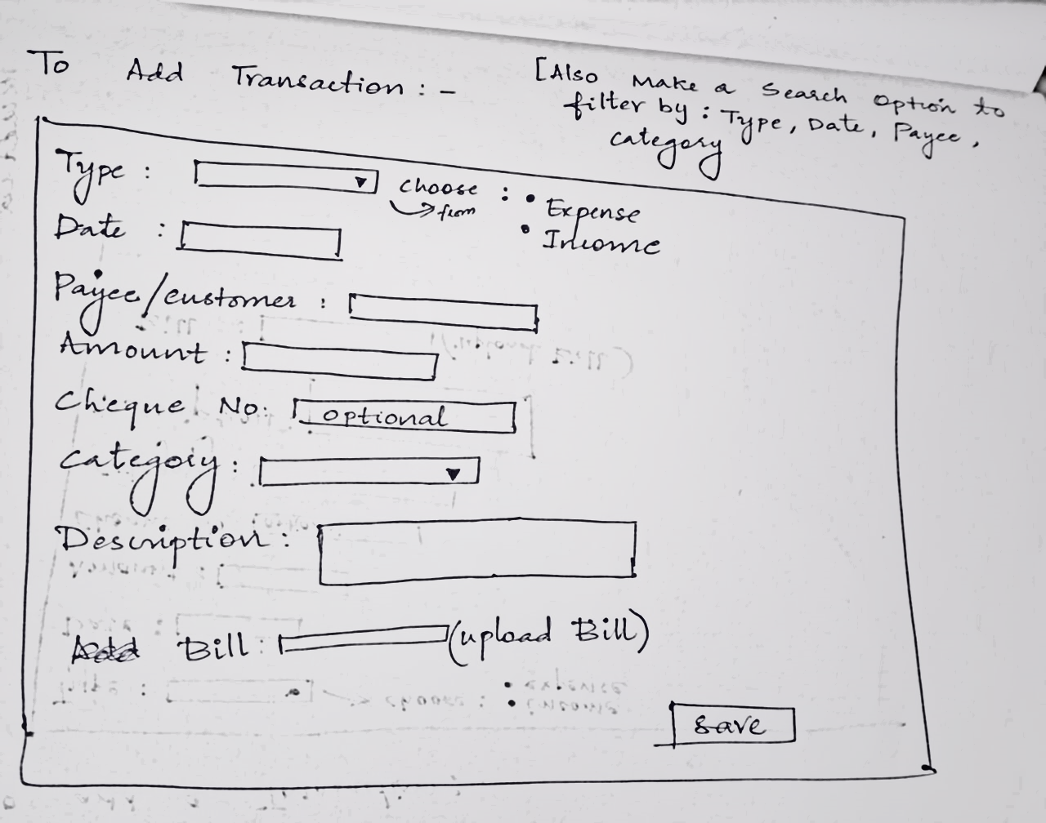

There is an option called category, for which one thing we can do is we can just type and input data, the other way is that we can add categories previously and just choose from them.

We also need

* an option to edit the transaction option
* search transactions based on type, date, payee category

Also, display the expense and income like this use red for expense and use – sign to denote expenses

Use green for income and + sign to denote income

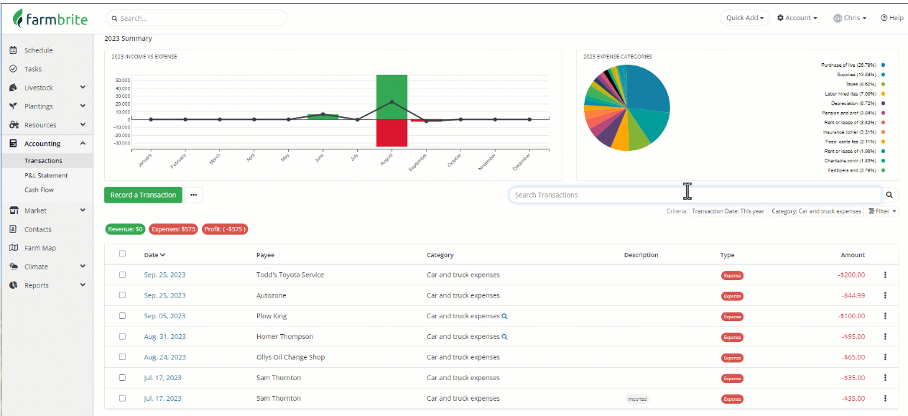

1. **In the P&L section :**

| **Profit and Loss Statement for ABC Farm** |
| --- |
| **Revenues** |

| **Description** | **Amount** |
| --- | --- |
| Wheat Sales | $3,000 |
| Corn Sales | $2,500 |
| Soybean Sales | $1,500 |
| Livestock Sales | $5,000 |
| Government Subsidy | $1,500 |
| Hay Sales | $1,000 |
| Renewable Energy (Solar) | $2,500 |
| **Total Revenue** | **$26,500** |
|  |  |
| **Expenses** |  |

| **Description** | **Amount** |
| --- | --- |
| Seeds | $1,200 |
| Fertilizers | $800 |
| Pesticides | $600 |
| Livestock Feed | $1,500 |
| Veterinary Services | $700 |
| Labor Wages | $5,000 |
| Utilities | $1,000 |
| Equipment Maintenance | $1,200 |
| Fuel | $500 |
| Rent | $2,000 |
| Insurance | $600 |
| Irrigation System Maintenance | $400 |
| Packaging Supplies | $300 |
| Office Supplies | $200 |
| **Total Expenses** | **$20,500** |
|  |  |
| **Net Profit** |  |

| **Description** | **Amount** |
| --- | --- |
| **Net Profit** | **$6,000** |
|  |  |

1. **Contact Management**

 Maintain Contact List of Important People:

* + Employees
  + Contractors
  + Vendors
  + Customers

It should be like : ( to add a new contact )

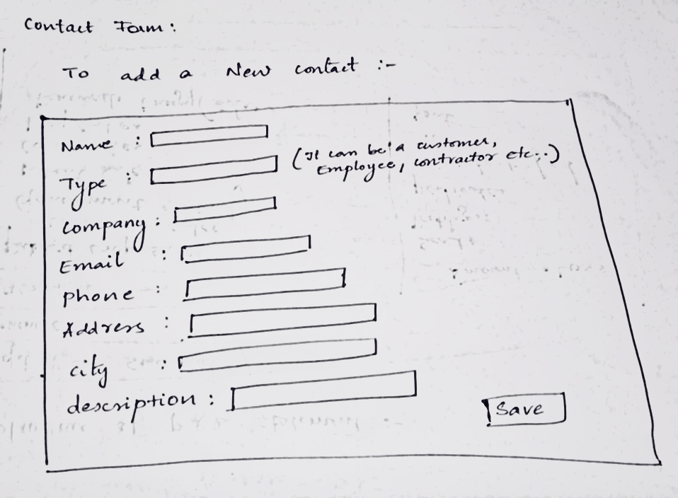

To view the added contact details :

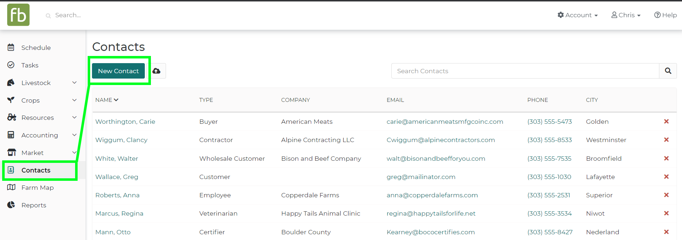

1. **Employee Management**

* Approve or reject employees requesting leave
* Receive complaints from employees ( accept or reject and reply to the complaints received)

1. **Notification Management**

We have a bell icon at the top right corner to receive notifications:

* + Receive notifications when a worker sends a leave request. The farm owner can click on it and directly go to a page where all the leave requests are present.
  + Receive notifications when the deadline is near for a task.
  + Receive notifications when workers send complaints

1. **Reports**

* Running events report from the scheduler (calendar)
* Assigned work report ( A report about the works assigned to workers and about if it's done, or in progress, etc...)
* Planting Summary Report- a report detailing the total number of plants planted
* Harvest summary Report- a report detailing the total number of plants Harvested
* Expense and Income report – we needed to show the expenses and income and also show a graph to describe them .

Something like this :



**WORKER MODULE**

1. **Authentication**

* Register/Login
  + First_name
  + Last_name
  + Image
  + Employee ID
  + Department
  + Position
  + Dob
  + Gender
  + Phone
  + Email
  + Address
  + Country

1. **Task Management**

 Task Todo

* + Create Personal To-Do Lists

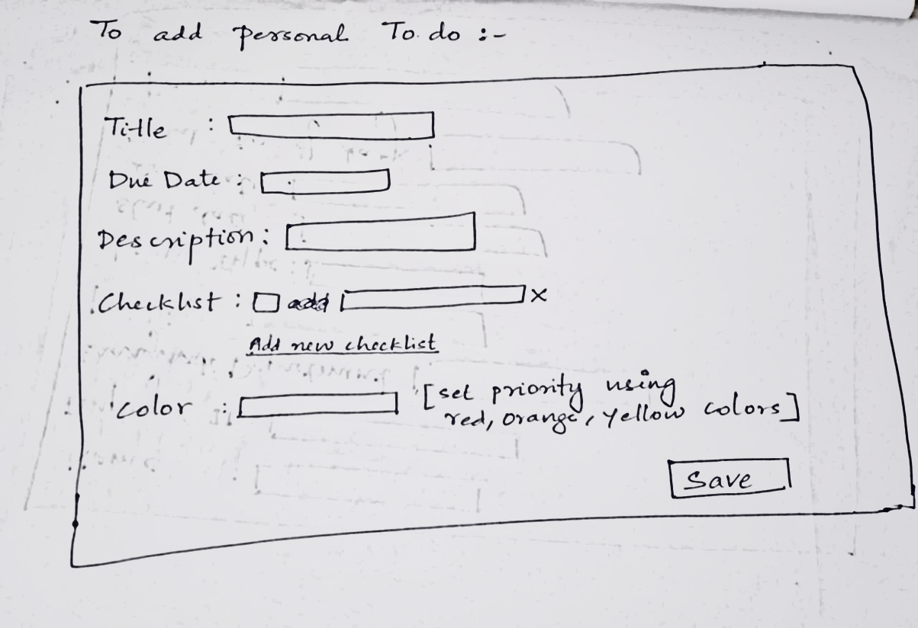

 View Assigned Work

View the assigned work details :

* + Title
  + Due Date
  + Description
  + priority
  + Update Work Status

3. **Notifications**

* Place a bell icon at the top right corner to display messages:
  + - Messages regarding assigned tasks for the workers.
    - Also, receive notifications about tasks that are approaching their deadline, marked as "urgent" in the message bell icon.
    - Receive replies from farmers for the registered complaints.

1. **Request for Leave**

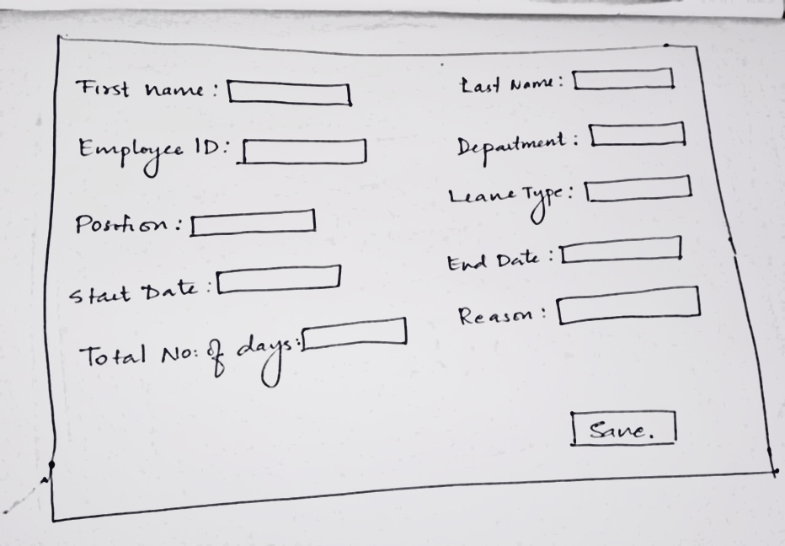

1. **Report complaints**

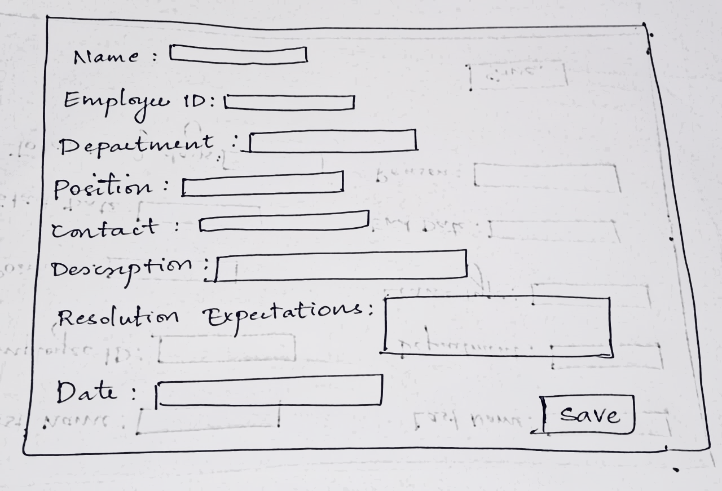

The worker should also receive a reply from the farmer : saying it can be resolved or not ( this will be received in the notification section)

1. **Reports**

* Report on the tasks and assigned work
* Report on leave records
* Report on personal To-dos